Ideation Phase Brainstorm & Idea Prioritization

|  |  |
| --- | --- |
| Date | 25 September 2022 |
| Team Id | PNT2022TMID40555 |
| Project Name | AI-powered Nutrition Analyzer for Fitness Enthusiasts |
| Maximum Marks | 4 Marks |

# Brainstorm

## Before you collaborate

A little bit of preparation goes a long way with this session. Here’s what you need to do to get going.

**10 minutes**

**1**

## Define your problem statement

What problem are you trying to solve? Frame your problem as a How Might We statement. This will be the focus of your brainstorm.

**5 minutes**

**2**

## Brainstorm

Write down any ideas that come to mind that address your problem statement.

**10 minutes**

**3**

## Group ideas

Take turns sharing your ideas while clustering similar or related notes as you go. Once all sticky notes have been grouped, give each cluster a sentence-like label. If a cluster is bigger than six sticky notes, try and see if you and break it up into smaller sub-groups.

**20 minutes**

**4**

## Prioritize

Your team should all be on the same page about what's important moving forward. Place your ideas on this grid to determine which ideas are important and which are feasible.

**20 minutes**

## After you collaborate

You can export the mural as an image or pdf to share with members of your company who might find it helpful.

**Quick add-ons**

# & idea prioritization

### Use this template in your own

**A Team gathering**

Define who should participate in the session and send an

invite. Share relevant information or pre-work ahead.

**Set the goal**

**PROBLEM**

Nutritional analysis is the process of determining the nutritional content of food. It is a vital part of analytical chemistry that provides information about the chemical

**Bojja sahith**

Maintain the daily food habits and menus

Measuring the

Check the quantity of food

**B.Mahendra**

Suggests food based on their health conditions

Tracking

Tracking health care plan of an individual

**Ch.somanadh**

Asks to enter the weight and

height to calculate BMI

Maintain the

A s s is ts nutrientr ic h fo o d s

bas ed on the ir he a lth

co nd ition s

**Hari krishnan**

Tracking Food Consumption

Calories estimation

**A Share the mural**

**Share a view link** to the mural with stakeholders to keep them in the loop about the outcomes of the session.

### brainstorming sessions so your team

can unleash their imagination and start shaping concepts even if you're not sitting in the same room.

**B**

Think about the problem you'll be focusing on solving in

the brainstorming session.

**C Learn how to use the facilitation tools**

Use the Facilitation Superpowers to run a happy and

composition, processing, quality control and contamination of food.The main aim of the project is to building a model which is used for classifying the fruit depends on the different characteristics like colour, shape, texture etc. Here the user can capture the images of different fruits and then the image will be sent the trained model. The model

Indicates calories content of daily taken food

physical and

chem ica l components in the food

Remember the diet plans and BMI of the body

Estimate the nutrition level

calories in the

food by uploading images

Suggests regular physical activities for good health

Aw a rds the use r w h o ta k e s

b a la n c e d

nutrient-food on da ily b a s is

daily food habits and menus

Calculate the nutr ient con te nt in their food by uploading images

Tracking calories in the food by uploading images

Nutrition

Facts

FAQs

**B Export the mural**

Export a copy of the mural as a PNG or PDF to attach to emails, include in slides, or save in your drive.

**10 minutes** to prepare

Nutrition Facts

**1 hour** to collaborate

**2-8 people** recommended

productive session.

[**Open article**](https://support.mural.co/en/articles/2113740-facilitation-superpowers)

analyses the image and detect the nutrition based on the fruits like (Sugar, Fibre, Protein, Calories, etc.).

#### Key rules of brainstorming

To run an smooth and productive session

#### Keep moving forward

**Strategy blueprint**

Define the components of a new idea or strategy.

[**Open the template**](https://app.mural.co/template/e95f612a-f72a-4772-bc48-545aaa04e0c9/984865a6-0a96-4472-a48d-47639307b3ca)

**Customer experience journey map**

Remember the diet plans and BMI of the body

Stay in topic.

Defer judgment.

Encourage wild ideas.

Listen to others.

#### Importance

If each of these

Suggests regular physical activities for good health

Understand customer needs, motivations, and obstacles for an experience.

[**Open the template**](https://app.mural.co/template/b7114010-3a67-4d63-a51d-6f2cedc9633f/c1b465ab-57af-4624-8faf-ebb312edc0eb)

Go for volume. If possible, be visual.

tasks could get

done without any difficulty or cost, which would have the most positive impact?

**Strengths, weaknesses, opportunities & threats**

Identify strengths, weaknesses, opportunities, and threats (SWOT) to develop a plan.

Tracking calories in the food by uploading images

[**Open the template**](https://app.mural.co/template/6a062671-89ee-4b76-9409-2603d8b098be/ca270343-1d54-4952-9d8c-fbc303ffd0f2)

[**Share template feedback**](https://muralco.typeform.com/to/CiqaHVat?typeform-source=app.mural.co)

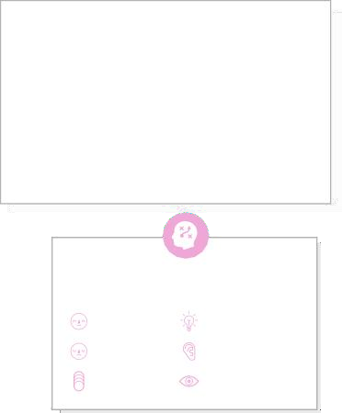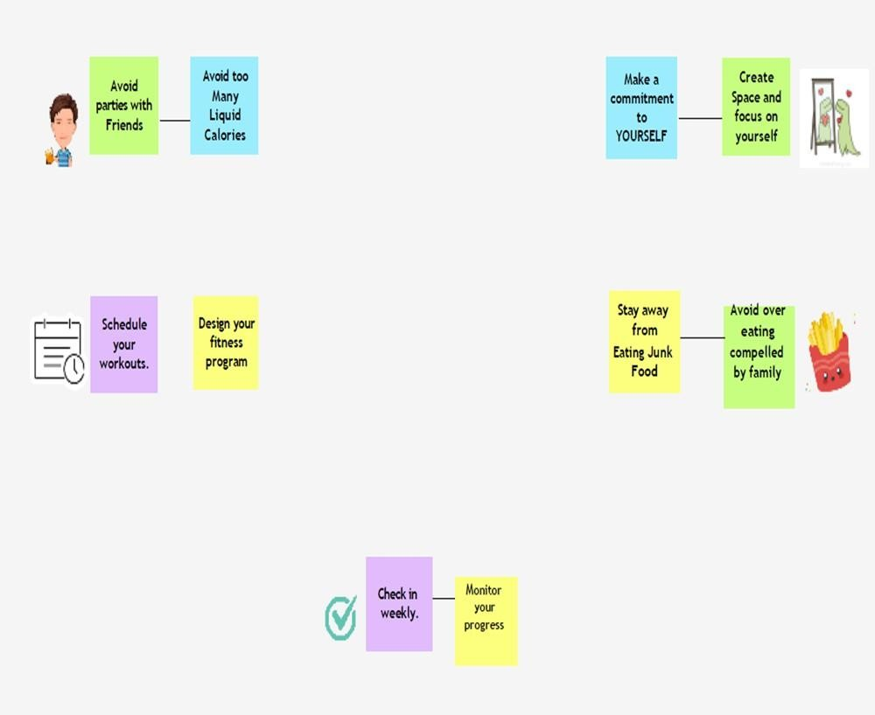

**Template**

[**Share template feedback**](https://muralco.typeform.com/to/CiqaHVat?typeform-source=app.mural.co)

#### Feasibility

Regardless of their importance, which tasks are more feasible than others? (Cost, time, effort, complexity, etc.)